**FIRST, if the server is 2016, do the DOT Net 3.5 Install Document. If not 2016, continue.**

**SECOND, check to see if an SQL Agent is on the server by following the below path on the physical. server**

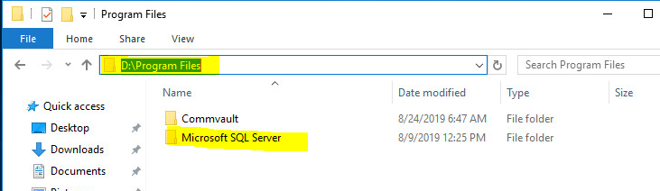

**Third, if no SQL Agent is installed, follow the below steps.**

Under Client Computer Groups, find the “No SQL Installed” and right click, Properties (if do not see the servers displayed, close/open Commvault)

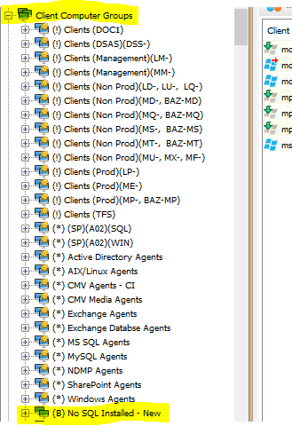

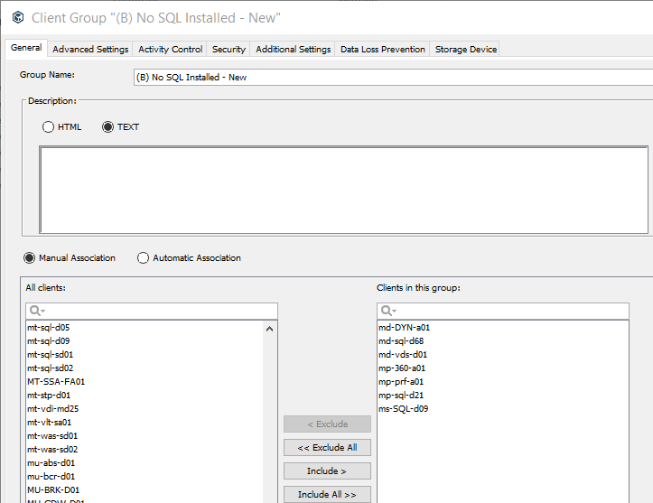

SQL Setup:

Find the server in Commvault, expand the sql server, right click in the “Subclient Name” click properties and select settings shown in each tab.

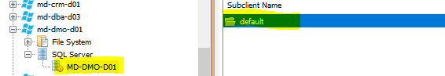

General:

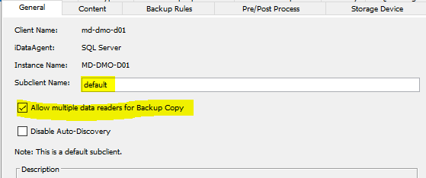

Activity Control:

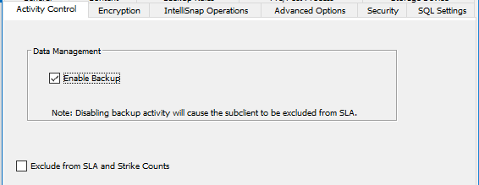

Encryption:

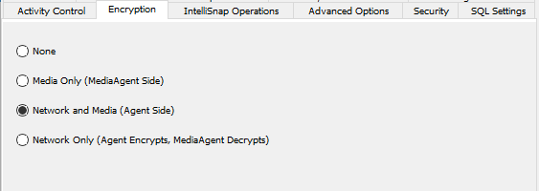

IntelliSnap Operations: (Leave Blank)

Advanced Options: (Leave Blank)

Security: (Leave Blank)

SQL Settings:

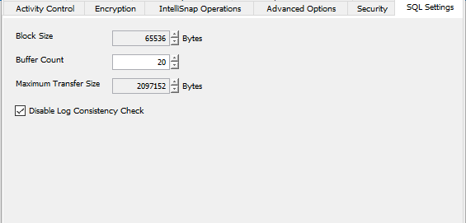

Content: **(To add db’s, click configure tab, then discover. In the Subclient Name column, click in the empty box and select the default option for each, then click ok).**

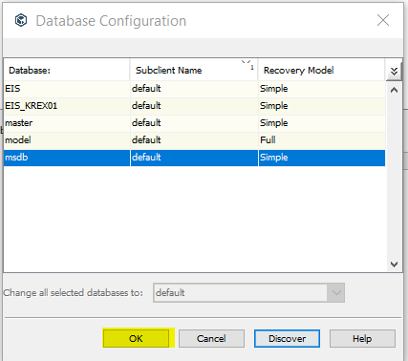

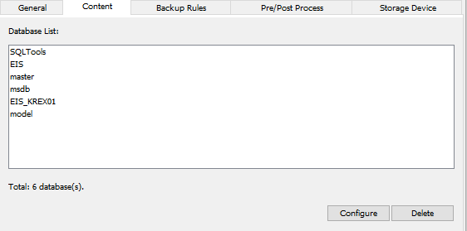

Backup Rules:

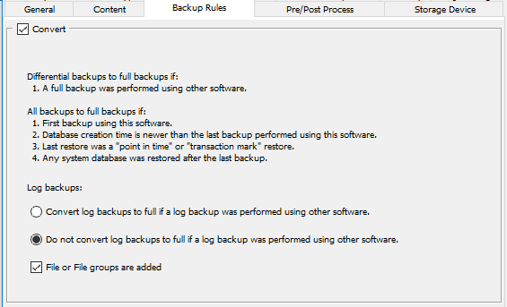

Pre/Post Process: (Leave Blank)

Storage Device: (Choosing Storage Policy, choose either MM-CMV-SF01,SF05 or SF20)

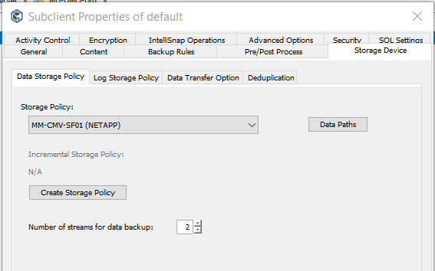

Still under the Storage Device tab, choose the “Log Storage Policy”. Choose either SF10 or SF24.

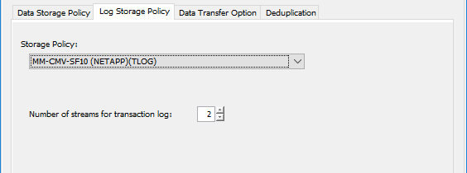

Still under the Storage Device tab, choose the “Data Transfer Option Tab”.

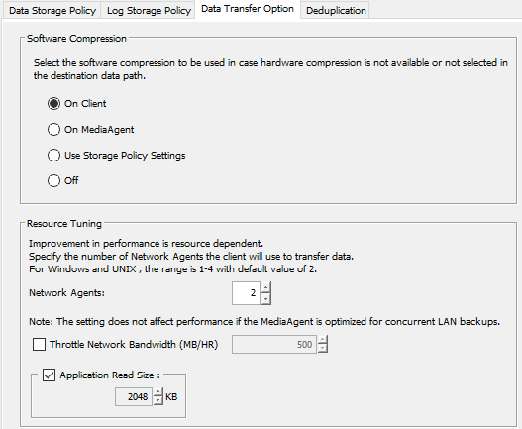

Still under the Storage Device tab, choose the “Deduplication”.

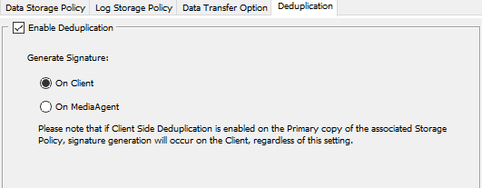

Scroll down to “Policies.” Expand policies, click on schedule policies, depending on test, dev or prod server, scroll to find the group type of server you are installing. Example, this server is mu….

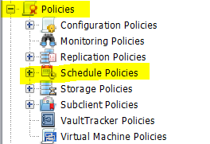

The “Associated Clients” columns list displays the max amount of servers for that schedule. Example, the mu group, the max allowed is 10. On the selected group in blue there is only 1 server currently in there, so I chose this one. **(Be sure to choose SQL group, not Windows when choosing schedule for SQL).**



Right click the schedule you chose, edit, click on the “Associations” tab, then click the “edit” tab, find the server you chose and select it, then click ok.

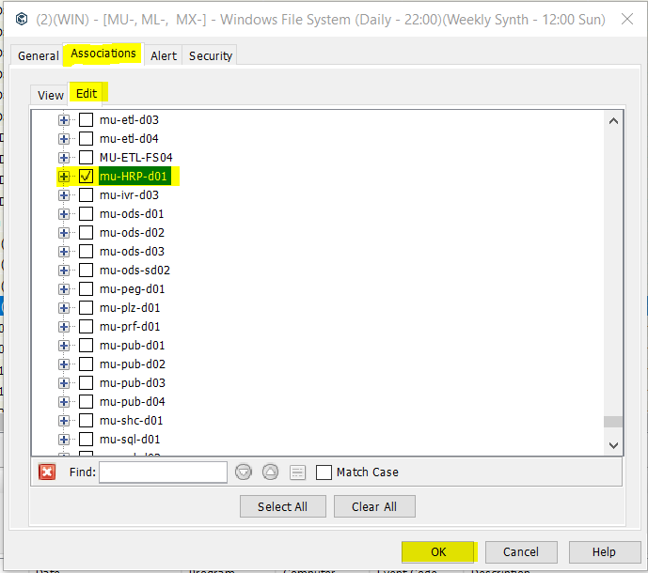

**TLOG Schedules: Only For Production.**

